**SED is Stream Editor**

- Main utility is to find and replace regex pattern in a given file

- sed -i '/regex_to_be_substitued/regex_to_substitute' filename

eg. Sed - i ‘/manager/clerk/’ employee.txt

- Assignment :

Create use cases using 5 X Flags.

1. **Replacing or substituting string**

$cat employee.txt

$ sed ‘s/manager/peon/’ employee,txt

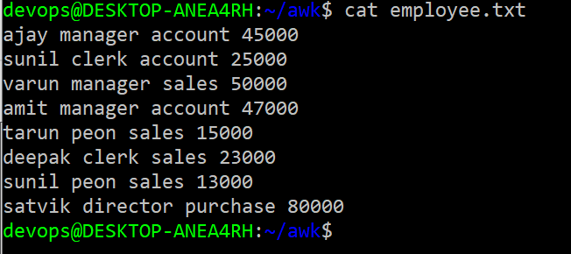

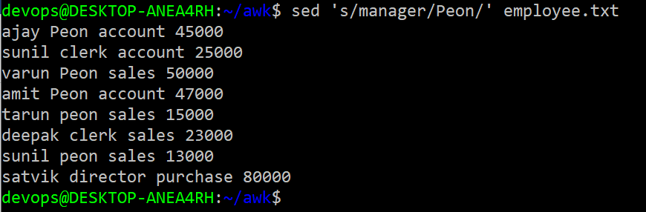

2. **Replacing the nth occurrence of a pattern in a line**

$ sed ‘s/clerk/manager/2’ employee.txt

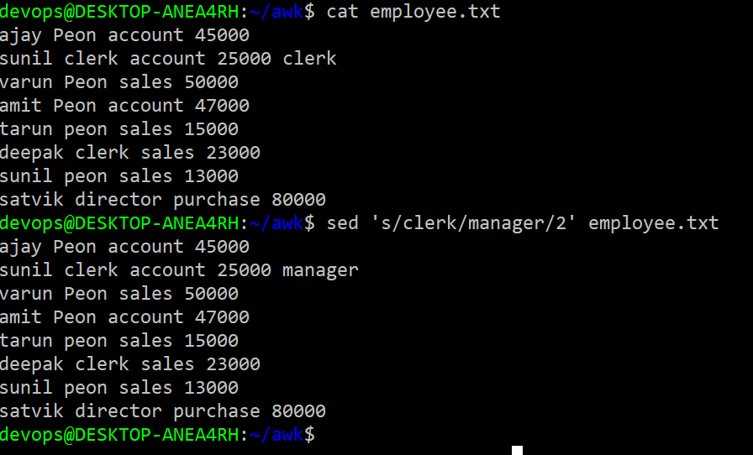

**3.Replacing all the occurrence of the pattern in a line**

Sed ‘s/clerk/manager/2g’ employee.txt

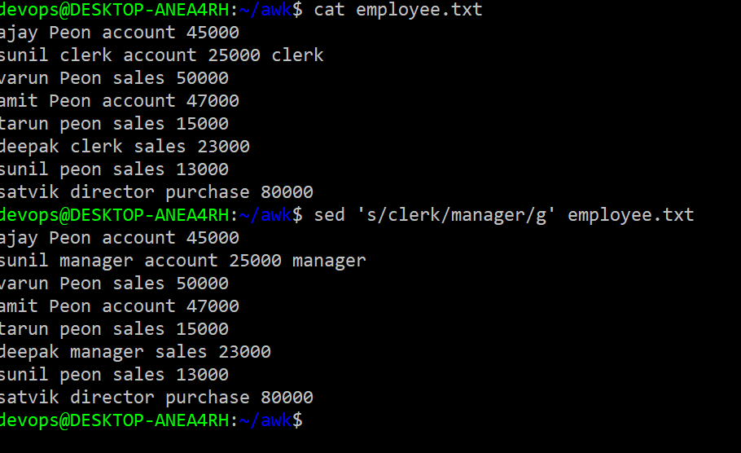

**4.Replacing from nth occurrence to all occurrences in a line**

Sed ‘s/clerk/manager/2g’ employee.txt

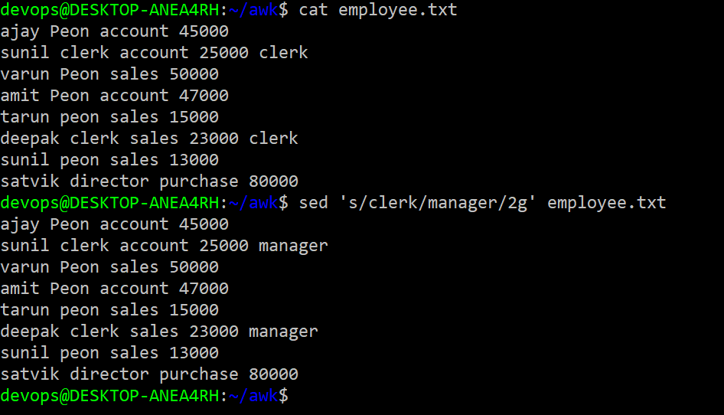

**5.Replacing string on a specific line number**

Sed ‘ 2 s/clerk/manager/’ employee.txt

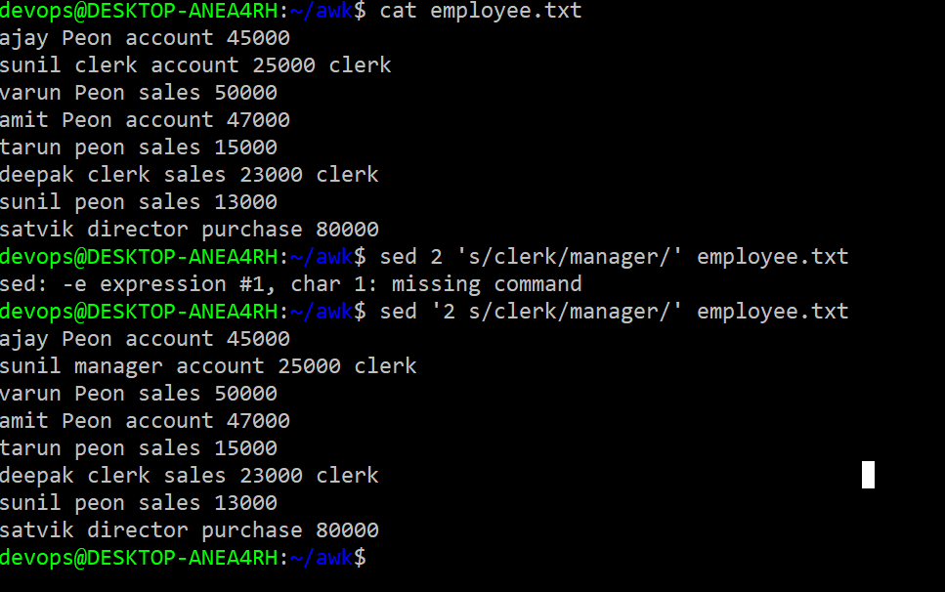

Create use cases exploring standard variables for sed.